# **HUE LIGHTS FREEBOARD WIDGET**

## Light/Lamp State Explanations

When Hue Light is OFFLINE (means not connected to power or not reachable by the Hue Bridge)



OFFLINE => The Base is Red

Example:



In example above, the Hue Light named “Hue Color Salon Cheminee” is OFF-LINE

When Hue Light is ONLINE (means connected to power and reachable by the Hue Bridge), the Base of the lamp will be Green. We can also address the fact when a Light is ONLINE then we can have the state of the Light (ON or OF). If the Lamp is ON then Radius will be on White else radius will stay Black for OFF.



ONLINE and ON => The Radius are in Black

ONLINE => The Base is Green



ONLINE and ON => The Radius are in White

The Color of the interior of Light is the configured color.

Example:



In example above, the Hue Light named “Hue Color White Escalier Bas” is ONLINE and the Light is ON with a 100% Light Intensity and White Color.



In example above, the Hue Light named “Hue Lightstrip TV” is ONLINE and the Light is ON with an 85% Light Intensity and a Blue Color is configured.

## Use of the Widget Hue Light

The installation of the widget is seen in another chapter; we assume here it is correctly installed.

The Data Source requested is also seen in another chapter, we assume here the data source is correctly installed and is name is HUE_LIGHTS.

Here are some explanations on each field of the widget:

**TITLE**: field shall not be filled, in this case the HUE_LIGHT Widget will get the information from the Hue Bridge and assigned the name configured for the Light.

**LIGHT ID**: This filed is required, it shall be greater or equal than 1. It represents the Id number of the Light return by the data source.

**HUE LIGHT DATA**: that field shall be datasource[“HUE_LIGHTS”]

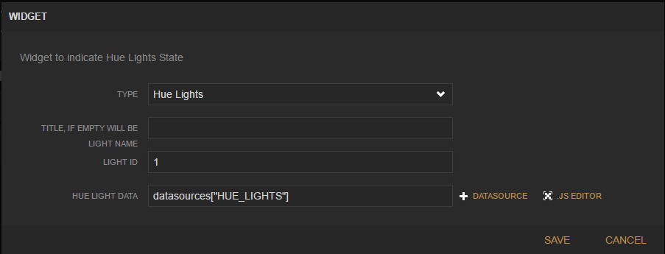

## Add the HUE_LIGHTS data source

The datasource requested by the widget is a JSON datasource. The JSON data expected are described in the chapter JSON PHP data. Let’s assume at this stage that the JSON data come from a php file named hue.php that you have installed in your home local server.

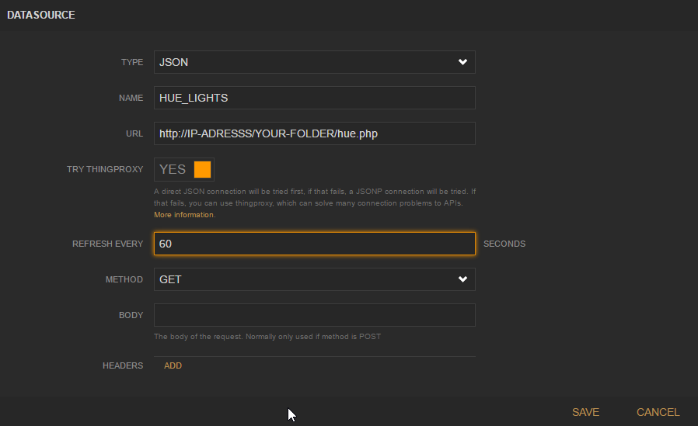

## Installation of the JSON PHP HUE file

Look inside the hue.php file, there is a configuration to perform: set your IP Hue Bridge API and set your API Key.

This php script provide whole information of the Lights from the Hue Bridge controller.

## Installation of the HUE LIGHT Widget

Edit the file index.html at the root of the freeboard directory and modify the script bloc like below

<script type="text/javascript">

head.js("js/freeboard_plugins.min.js",

**"plugins/freeboard/lights_hue.js",**

// *** Load more plugins here ***

function(){

$(function()

{ //DOM Ready

freeboard.initialize(true);

var hashpattern = window.location.hash.match(/(&|#)source=([^&]+)/);

if (hashpattern !== null) {

$.getJSON(hashpattern[2], function(data) {

freeboard.loadDashboard(data, function() {

freeboard.setEditing(false);

});

});

}

});

});

</script>

Copy the file lights_hue..js in the plugins/freeboard/ folder.

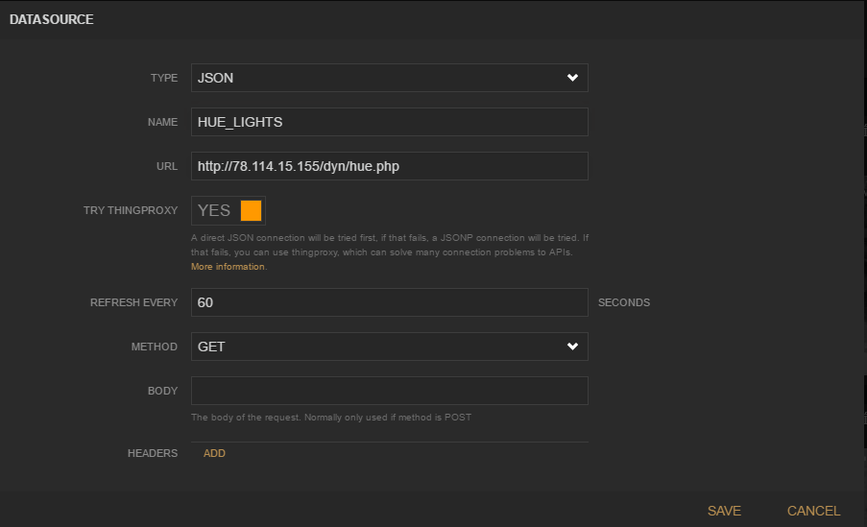

Screenshoot_HueLight_FreeBoard_Widget_1:

